DATA COLLECTION

Gather transaction data that includes information on what items were purchased together. This can be obtained from point-of-sales system or e-commerce platforms.

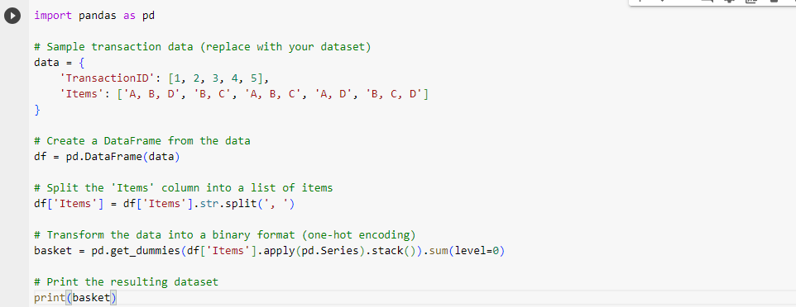

DATA PREPROCESSING

It is a crucial step in market basket analysis. Below is a python code snippet that covers the some common data preprocessing tasks such as removing duplicate, handling missing values and encoding categorical data for market basket analysis.

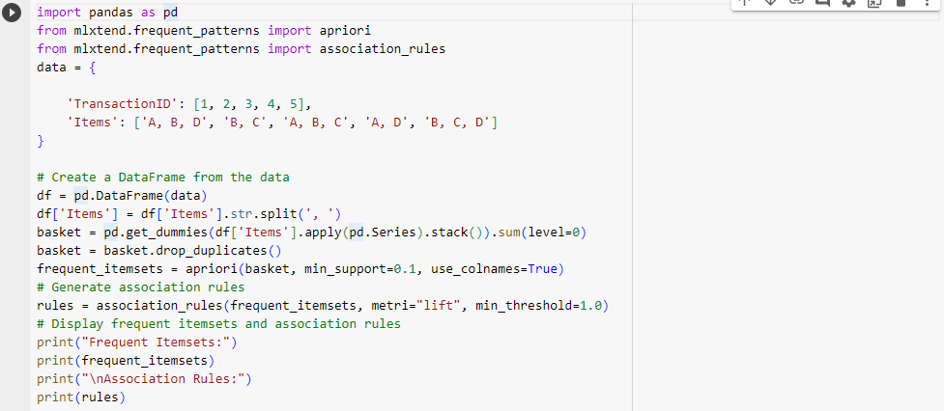

FEATURE ENGINEERING

Feature engineering typically involve creating new features or transforming

Existing once to improve the performance of a machine learning model this specific code for feature engineering can vary widely depending on data set

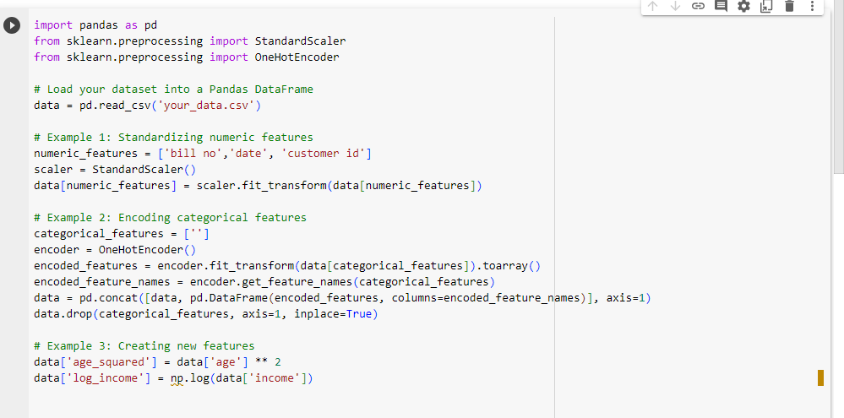

This is very basic example and feature for market basket analysis insights.

VISUALIZATION

Visualization data is essential part of data analysis and model interpretation. Here’s an example of how to create basic visualization library Matplotlib .you’ll need to have Matplotlip installed

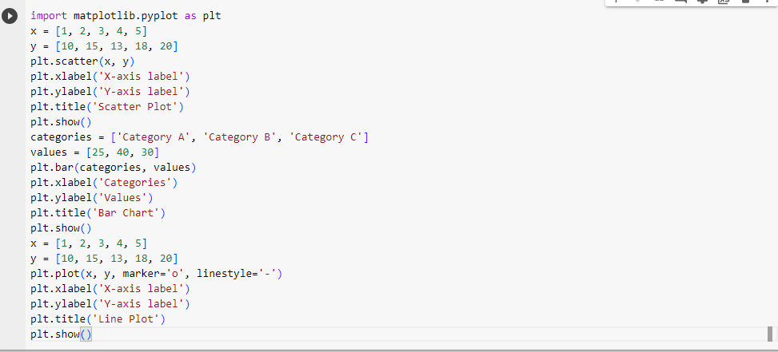

This is the very basic example for visualization in market basket analysis insights.

EVALUATION

It is the performance of machine learning models is crucial for understanding how well they’re doing .Here’s is the basic example of how to evaluate a classification model using python and scikit-learn

